NAME: Soham Saha

SECTION: CSE2A

CLASS ROLL: 61

ENROLLMENT NUMBER: 12019009001389

ASSIGNMENT DATE: 24TH MARCH,2021

SUBJECT: OOP JAVA

Q1)

class point

{

int x1,x2,y1,y2;

public point()

{

x1=5;

x2=10;

y1=4;

y2=10;

}

}

public class circle

{

public static void main(String args[])

{

point obj = new point();

/*

* according to the formule

* we have to find r

*/

double radius = Math.sqrt(Math.pow((obj.x2-obj.x1),2)+Math.pow((obj.y2-obj.y1),2));

double pi=3.14159,area=1;

area=pi*radius*radius;

System.out.println(area);

}

}

//area of cicle of a given point

/*

* r=sqrt((x2-x1)^2+(y2-y1)^2)

* then apply

* area=pi*r*r

*/

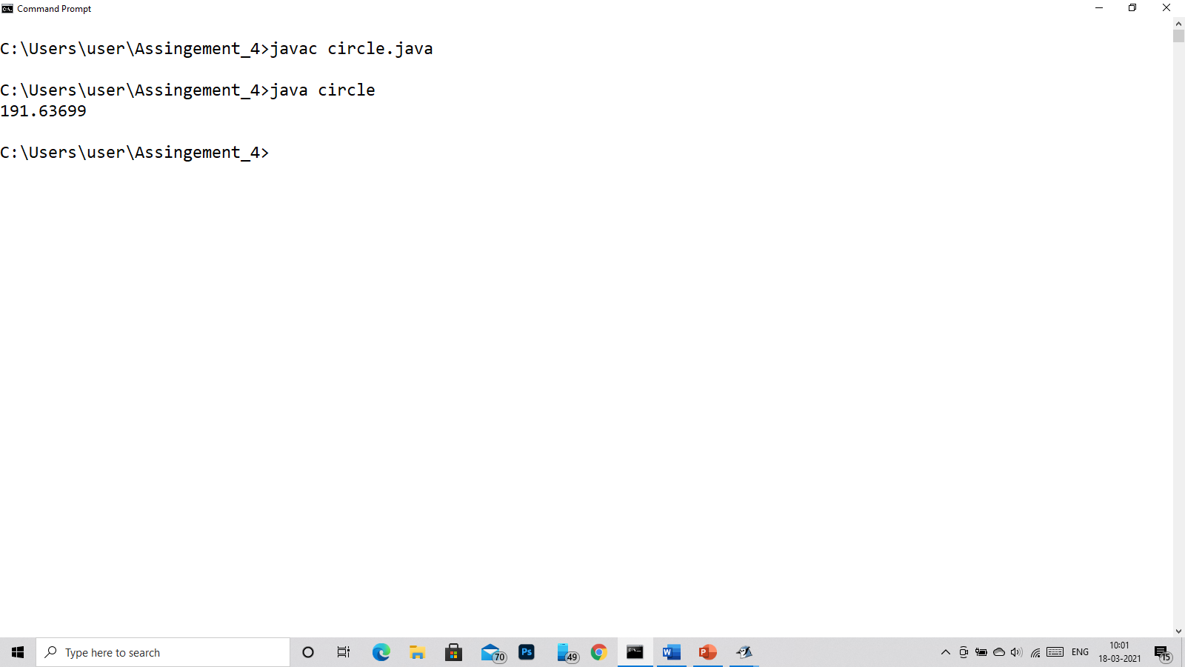

Q2)

class time

{

private int hour,min,sec;

time(int hour,int min,int sec)

{

this.hour=hour;

this.min=min;

this.sec=sec;

}

void add(time t)

{

int sum = t.hour+t.min+t.sec;

System.out.println(sum);

}

public static void main(String args[])

{

time t1 = new time(5,23,56);

time t2 = new time(4,32,44);

t1.add(t1);

t2.add(t2);

}

}

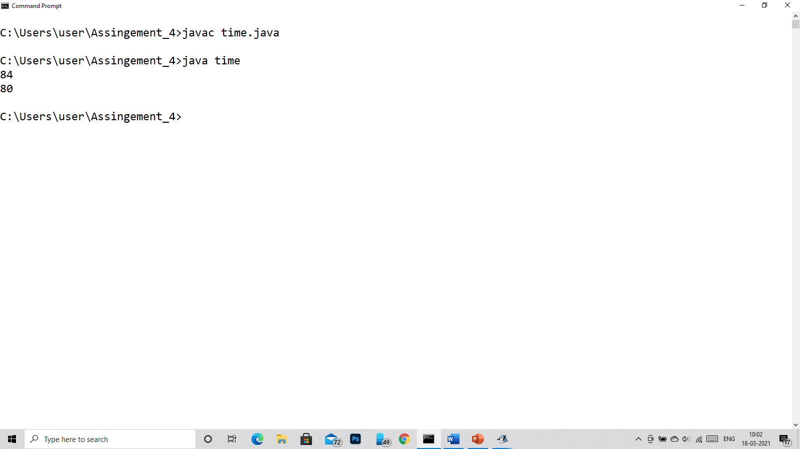

Q3)

class complex

{

private int real,img;

public complex(int real,int img)

{

this.real=real;

this.img = img;

}

void add(complex c)

{

System.out.println(c.real+"+"+c.img+"i");

}

public static void main(String ard[])

{

complex c1=new complex(3,4);

complex c2=new complex(-10,6);

c1.add(c1);

c2.add(c2);

}

}

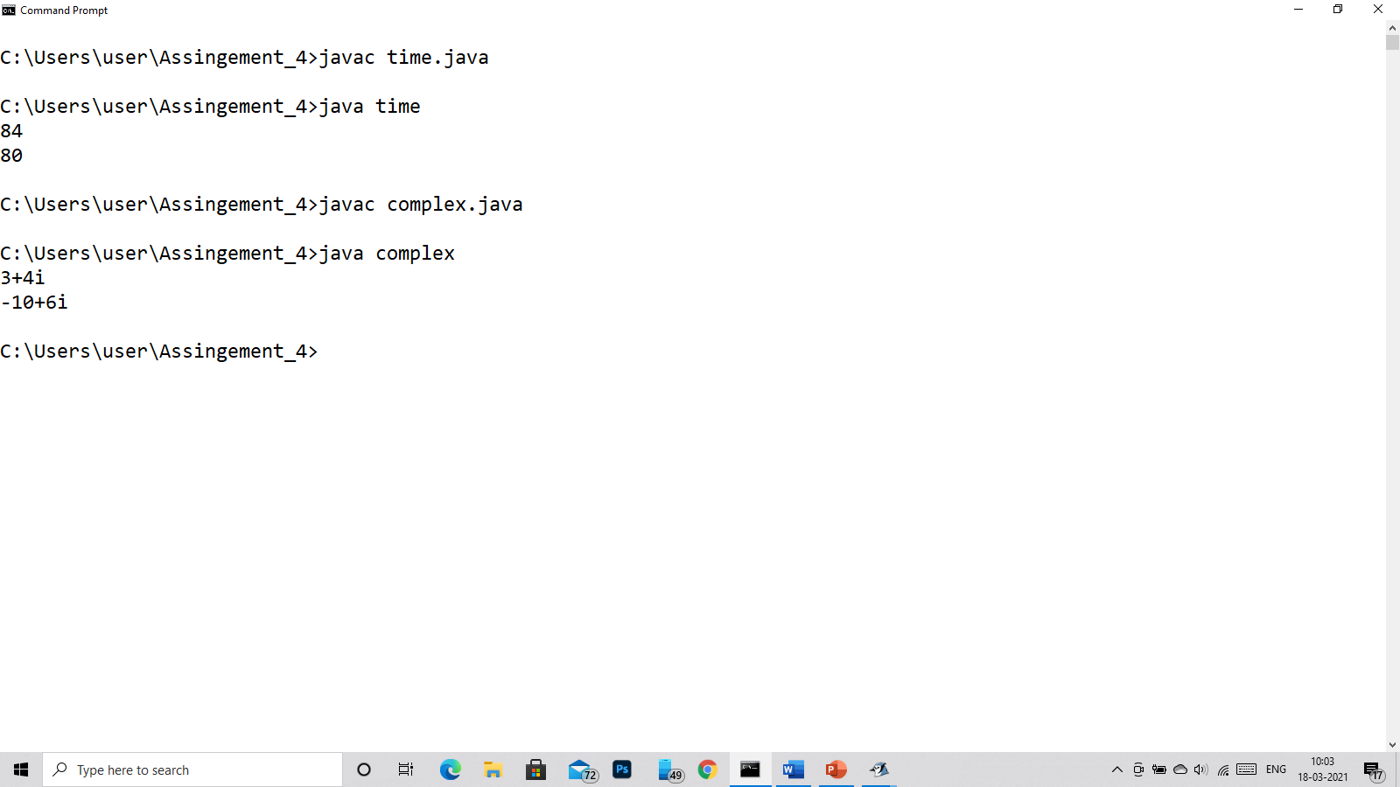

Q4)

class q4

{

private int num;

public q4()

{

this.num = 834;

}

public q4(int num)

{

this.num=num;

}

int rev()

{

int num = this.num;

int r=0,k;

while(num!=0)

{

k=num%10;

r=r*10+k;

num/=10;

}

return r;

}

public static void main(String afed[])

{

q4 obj = new q4(534);

System.out.println("The reverse is "+obj.rev());

}

}

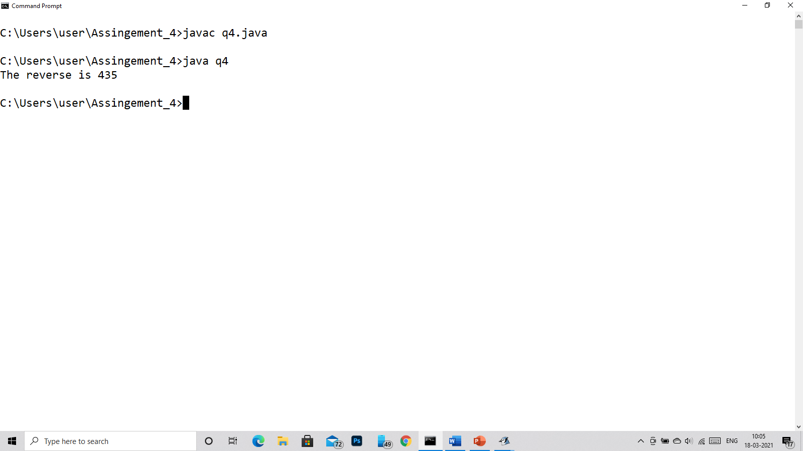

Q5)

class student

{

private int sub1,sub2,roll_no;

private String name;

public student()

{

name="Subhankar dutta";

sub1=90;

sub2=95;

roll_no=68;

}

public void init(String name,int roll_no,int sub1,int sub2)

{

this.name=name;

this.roll_no=roll_no;

this.sub1=sub1;

this.sub2=sub2;

}

public void display()

{

System.out.println("Your name: "+name);

System.out.println("Your roll number: "+roll_no);

System.out.println("Your subject marks 1: "+sub1);

System.out.println("Your subject marks 2: "+sub2);

int tot,per;

tot=sub1+sub2;

per=tot*100/200;

System.out.println("Your total marks is: "+tot);

System.out.println("Your total %age is: "+per);

}

public static void main(String ated[])

{

student stu = new student();

stu.init("Krishan",30,95,98);

stu.display();

}

}

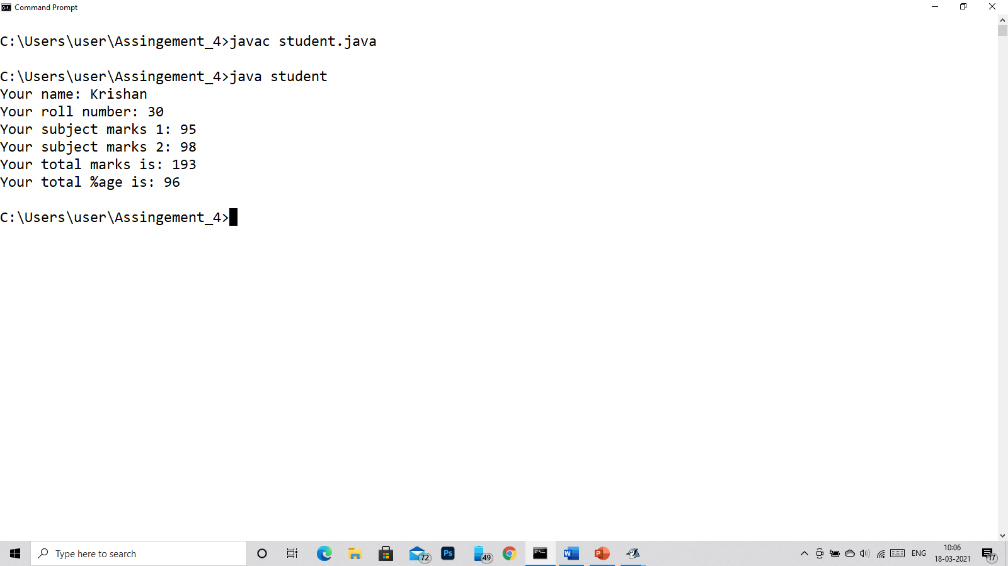

Q6)

class employee

{

int emp_id,basic_salary;

String emp_name;

employee()

{

emp_name="Subhankar dutta";

emp_id=1001;

basic_salary=10000;

}

public void init(String emp_name,int emp_id,int basic_salary)

{

this.emp_name= emp_name;

this.emp_id=emp_id;

this.basic_salary=basic_salary;

}

public void display()

{

int hra=basic_salary*10/100;

int da=basic_salary*15/100;

System.out.println("Your emp id is "+emp_id);

System.out.println("Your name is "+emp_name);

System.out.println("Your basic salary is "+basic_salary);

System.out.println("Your HRA is: "+hra);

System.out.println("Your DA is: "+da);

int sum =basic_salary+hra+da;

System.out.println("Your total gross salary is: "+sum);

}

public static void main(String af[])

{

employee emp = new employee();

emp.init("Vasu Dev Krishna",1002,50000);

emp.display();

}

}

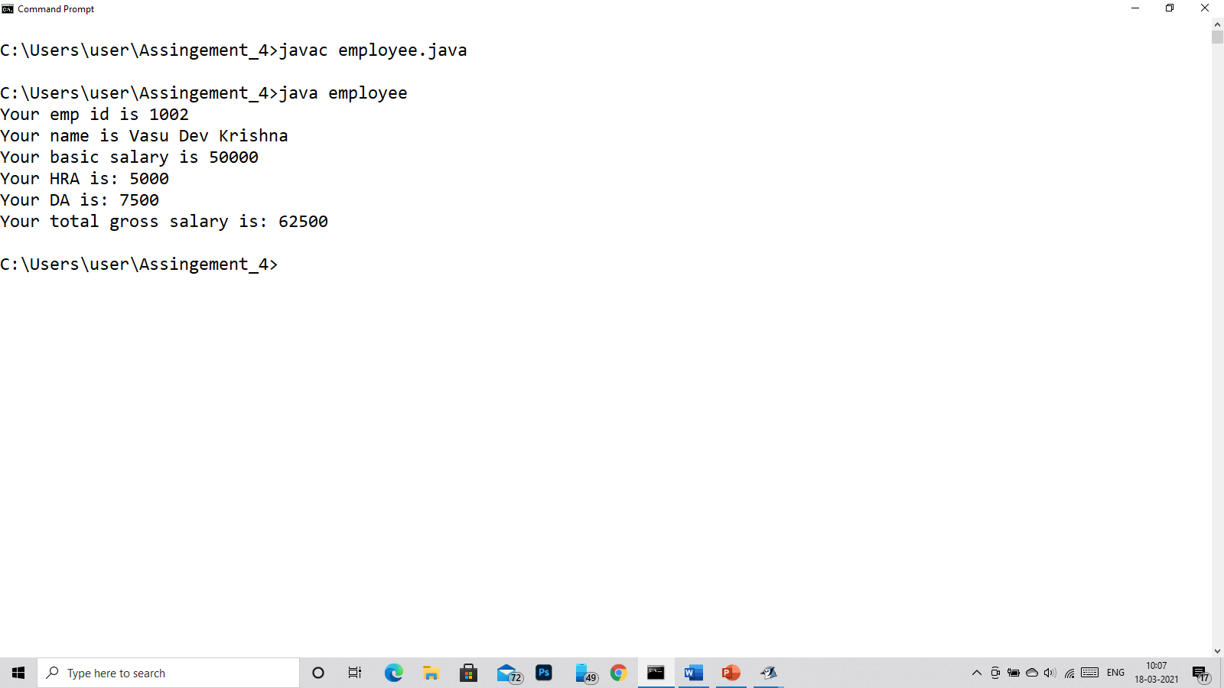

Q7)

class Fraction

{

private int numerator,denominator;

public Fraction()

{

numerator=68;

denominator=100;

}

public Fraction(int n,int d)

{

numerator=n;

denominator=d;

}

void display()

{

double fraction;

fraction=((double)numerator/(double)denominator);

System.out.println("The fraction of "+numerator+" and "+denominator+" is: "+fraction);

}

public static void main(String args[])

{

Fraction a = new Fraction(40,23);

Fraction b = new Fraction(20,43);

Fraction c = new Fraction(23,33);

a.display();

b.display();

c.display();

}

}

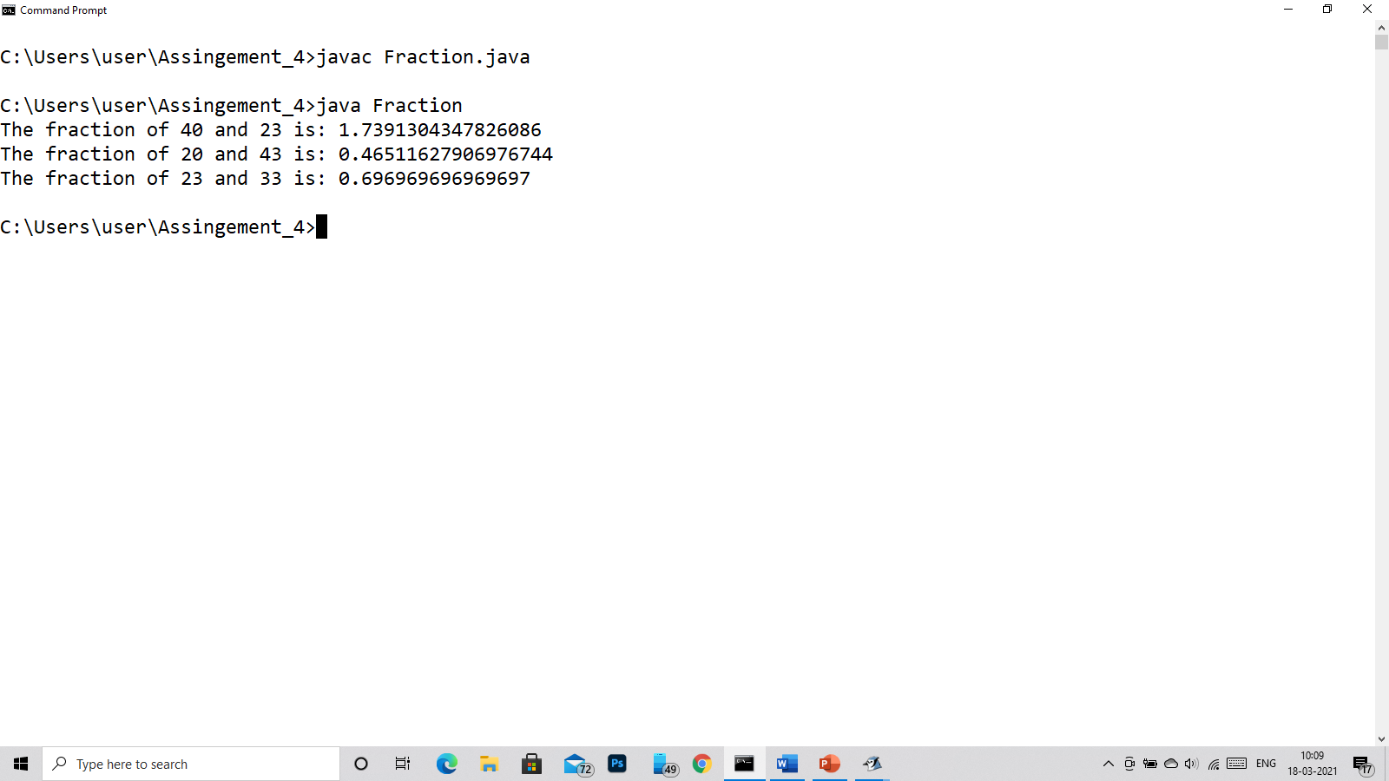

Q8)

class item

{

private int code,price;

item(int code,int price)

{

this.code=code;

this.price=price;

}

public static void main(String sde[])

{

int i,total=0;

item obj[] = new item[5];

obj[0] = new item(1001,400);

obj[1] = new item(1022,1000);

obj[2] = new item(1035,300);

obj[3] = new item(1004,600);

obj[4] = new item(1353,600);

System.out.println("+----------------------+-------------------------+");

System.out.println("| Code | Price |");

System.out.println("+----------------------+-------------------------+");

for(i =0;i<5;i++)

{

System.out.println("| "+obj[i].code+" | "+obj[i].price+" |");

total+=obj[i].price;

}

System.out.println("+----------------------+-------------------------+");

System.out.println("+-----Total: -+ "+total+" +");

System.out.println("+----------------------+-------------------------+");

}

}

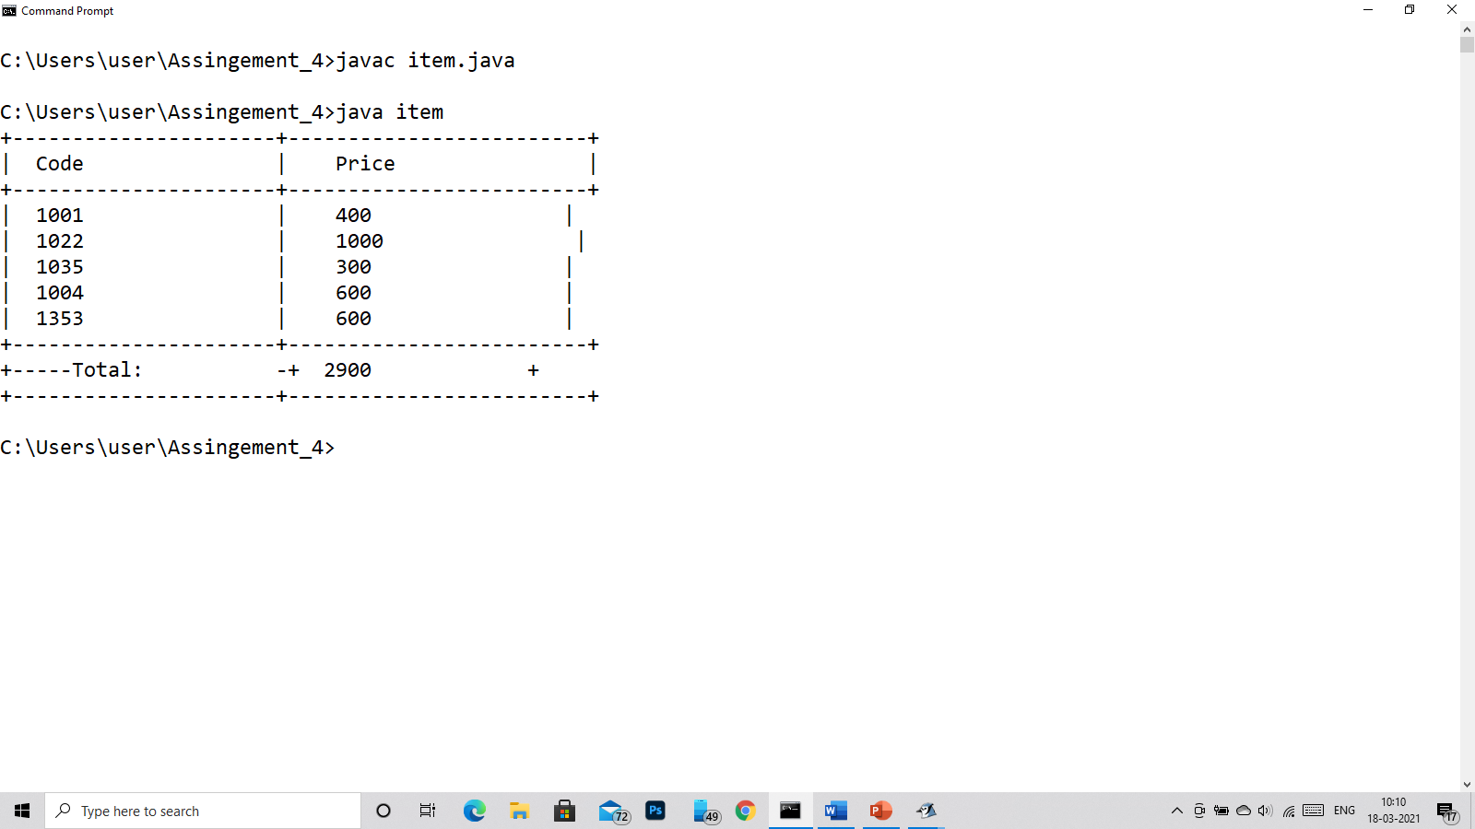

Q9)

class Tender

{

private String name;

private long cost;

Tender(String name,long cost)

{

this.name=name;

this.cost=cost;

}

public static void main(String sde[])

{

long total=0;

int i,k=0;

Tender obj[] = new Tender[5];

obj[0] = new Tender("DAYAL ENTERPRISES",44000000);

obj[1] = new Tender("POWER GROUP",25000000);

obj[2] = new Tender("POWER INFRAMET",23045000);

obj[3] = new Tender("POWER CONSTRUCTIONS",90000000);

obj[4] = new Tender("RS CONSRTUCTIONS",32000000);

long min = obj[0].cost;

for(i =0;i<5;i++)

{

if(min>obj[i].cost)

{

k=i;

min = obj[i].cost;

}

}

System.out.println("+----------------------+-------------------------+");

System.out.println("| Name | Min Cost |");

System.out.println("+----------------------+-------------------------+");

System.out.println("+ "+obj[k].name+" | "+obj[k].cost+" |");

System.out.println("+----------------------+-------------------------+");

}

}

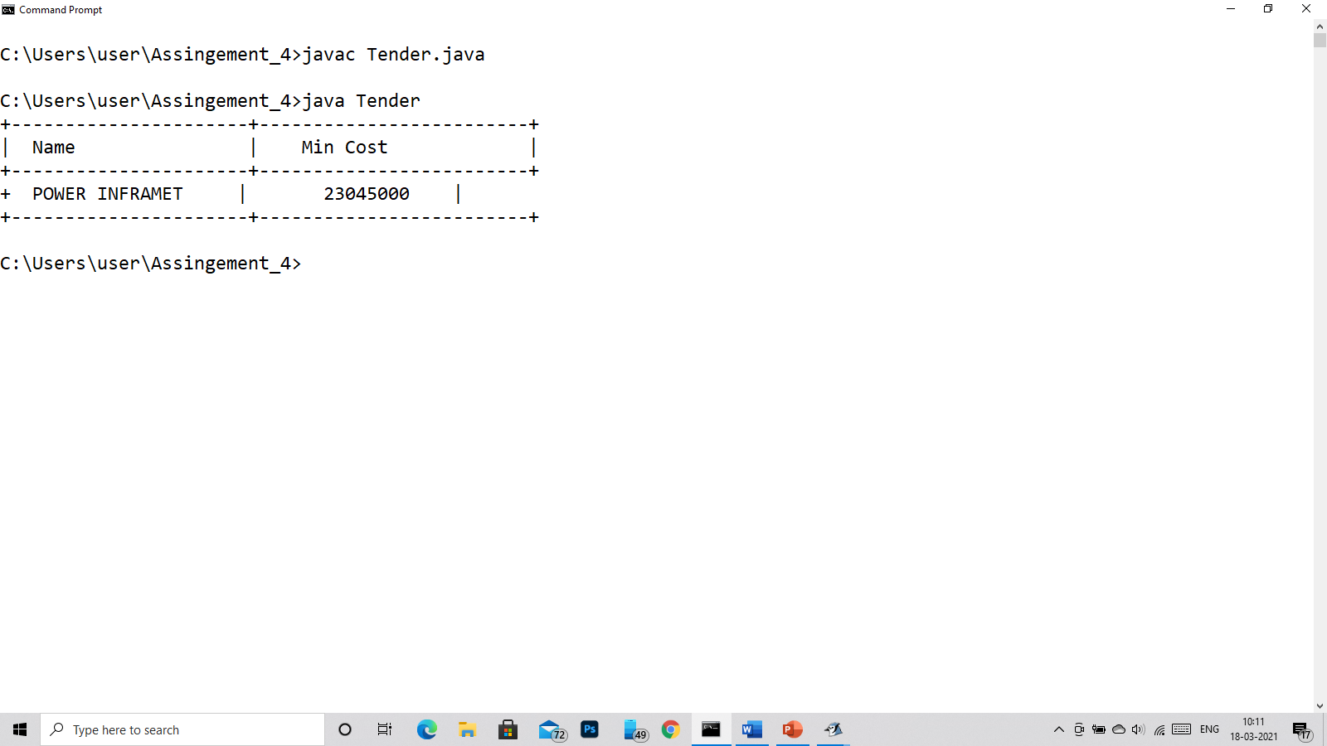

Q10)

class employeearr

{

int emp_id,basic_salary;

String emp_name;

employeearr()

{

emp_name="Subhankar dutta";

emp_id=1001;

basic_salary=10000;

}

public employeearr(String emp_name,int emp_id,int basic_salary)

{

this.emp_name= emp_name;

this.emp_id=emp_id;

this.basic_salary=basic_salary;

}

public static void main(String af[])

{

int i;

employeearr emp[] = new employeearr[5];

emp[0]=new employeearr("Vasu Dev Krishna",1000,50000);

emp[1]=new employeearr("Gopal",1001,33000);

emp[2]=new employeearr("Aachut",1002,23030);

emp[3]=new employeearr("Vishnu",1003,53000);

emp[4]=new employeearr("Kalki",1004,43000);

System.out.println("+------------------------+------------------------+----------+");

System.out.println("| Emp ID | Name | Salary|");

System.out.println("+------------------------+------------------------+----------+");

for(i =0;i<5;i++)

{

System.out.println("| "+emp[i].emp_id+" | "+emp[i].emp_name+" | "+emp[i].basic_salary+"|");

}

System.out.println("+------------------------+------------------------+----------+");

}

}

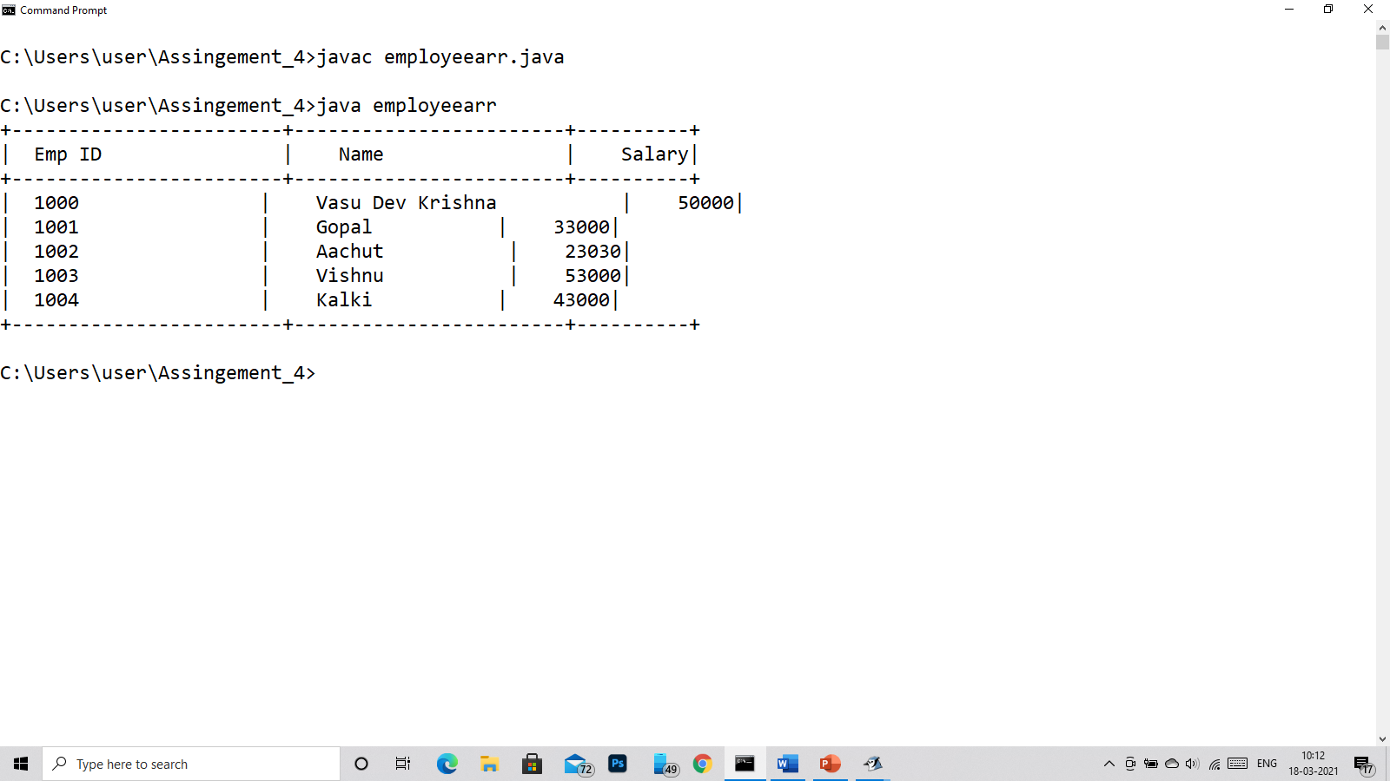

Q11)

class BigCircle

{

private double radius;

private String color;

BigCircle()

{

radius=1.0;

color="red";

}

BigCircle(double radius,String color)

{

this.radius=radius;

this.color=color;

}

private double getRadius()

{

return this.radius;

}

private String getColor()

{

return this.color;

}

public static void main(String args[])

{

BigCircle obj1 = new BigCircle();

BigCircle obj2 = new BigCircle(5.3,"Green");

System.out.println("The Radius of Circle 1 is "+obj1.getRadius()+" the color of this circle is "+obj1.getColor());

System.out.println("The Radius of Circle 2 is "+obj2.getRadius()+" the color of this circle is "+obj2.getColor());

}

}

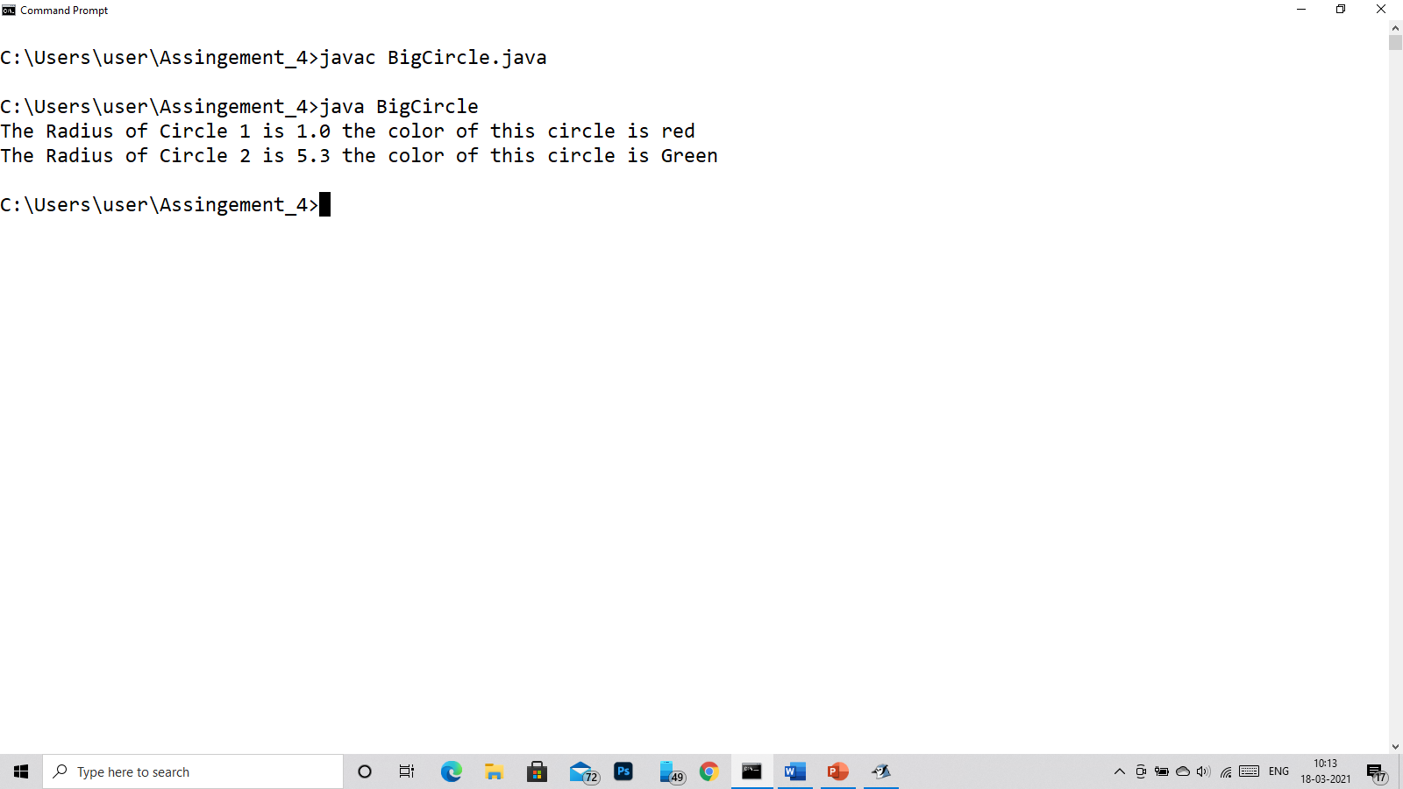

Q12) class q12

{

void PrintNumberInWord(int n)

{

switch(n)

{

case 0:

System.out.print(" ZERO");

break;

case 1:

System.out.print(" ONE");

break;

case 2:

System.out.print(" TWO");

break;

case 3:

System.out.print(" THREE");

break;

case 4:

System.out.print(" FOUR");

break;

case 5:

System.out.print(" FIVE");

break;

case 6:

System.out.print(" SIX");

break;

case 7:

System.out.print(" SEVEN");

break;

case 8:

System.out.print(" EIGHT");

break;

case 9:

System.out.print(" NINE");

break;

default:

System.out.println("\nError");

}

}

public static void main(String args[])

{

q12 obj= new q12();

obj.PrintNumberInWord(1);

obj.PrintNumberInWord(2);

obj.PrintNumberInWord(6);

obj.PrintNumberInWord(11);

}

}

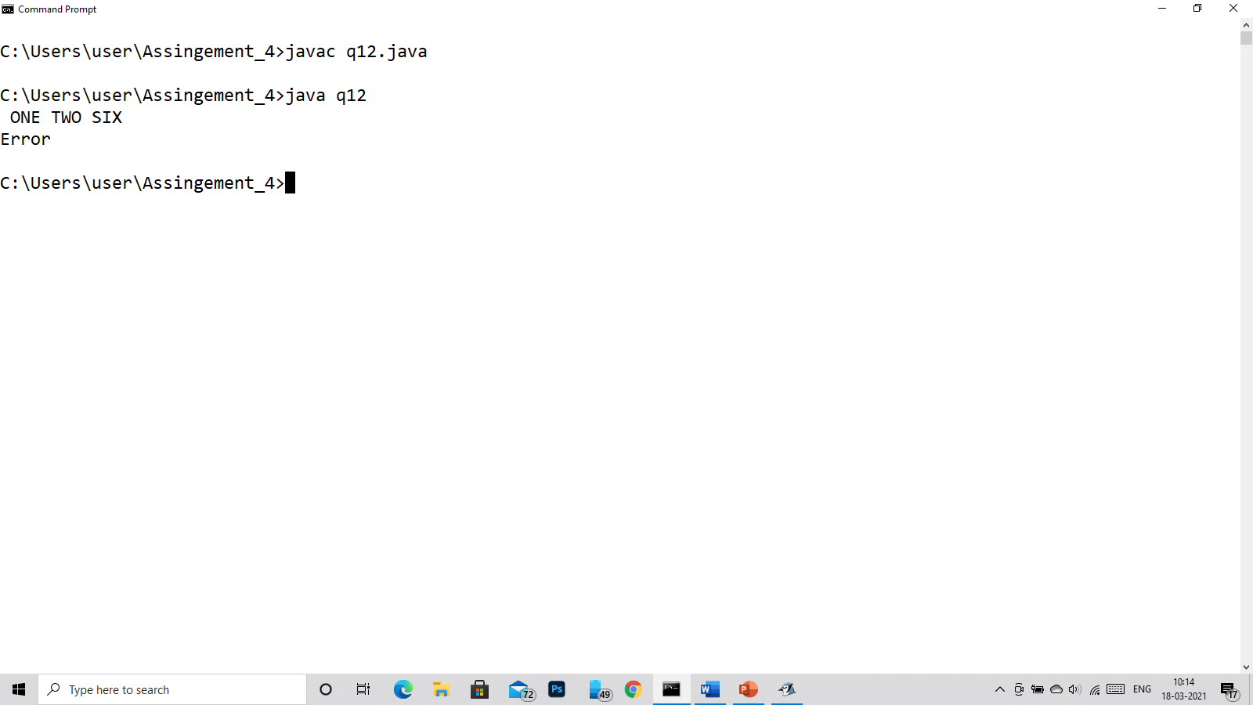

Q13)

import java.util.*;

class Account

{

private int id;

private double balance;

private double annualInterestRate;

private Date dateCreated;

//constructor

Account()

{

id=0;

balance = 0;

annualInterestRate=0;

}

Account(int id,double balance)

{

this.id = id;

this.balance = balance;

}

//Getter and Setter

public void setId(int id)

{

this.id=id;

}

public void setBalance(double balance)

{

this.balance=balance;

}

public void setAnnualInterestRate(double annualInterestRate)

{

this.annualInterestRate=annualInterestRate;

}

public int getId()

{

return id;

}

public double getBalance()

{

return balance;

}

public double getAnnualInterestRate()

{

return annualInterestRate;

}

public Date getDate()

{

dateCreated = new Date();

return dateCreated;

}

public double getMonthlyInterestRate()

{

double rate;

rate = annualInterestRate;

return rate;

}

public double getMonthlyInterest()

{

double intrest = getMonthlyInterestRate()*balance/100;

return intrest;

}

public void withdraw(double amt)

{

if(amt>=getBalance())

{

System.out.println("Not enough amount");

}

else

{

balance = balance - amt;

}

}

public void deposit(double amt)

{

balance += amt;

}

}

public class Person

{

public static void main(String args[])

{

/*

* Account ID =1020

* Initial Balance is 20000

*/

Account act = new Account();

act.setId(1020);

act.setBalance(20000);

act.setAnnualInterestRate(7.5);

//printing the current Accounts detials

System.out.println("Your ID: "+act.getId());

System.out.println("Your Current Balance is : "+act.getBalance());

System.out.println("Your Annual Intrest Rate is: "+act.getAnnualInterestRate());

System.out.println("Your Account Date opening is: "+act.getDate());

System.out.println("Your Monthly Intrest Rate is: "+act.getMonthlyInterestRate());

System.out.println("Your Monthly Intrest is: "+act.getMonthlyInterest());

System.out.println("Now i am withdraw 5000 Rs. from my account...");

act.withdraw(5000);

System.out.println("Now My current Balance is: "+act.getBalance());

System.out.println("Now i am Depositing 2000 Rs. in my account...");

act.deposit(2000);

System.out.println("Now My current Balance is: "+act.getBalance());

}

}

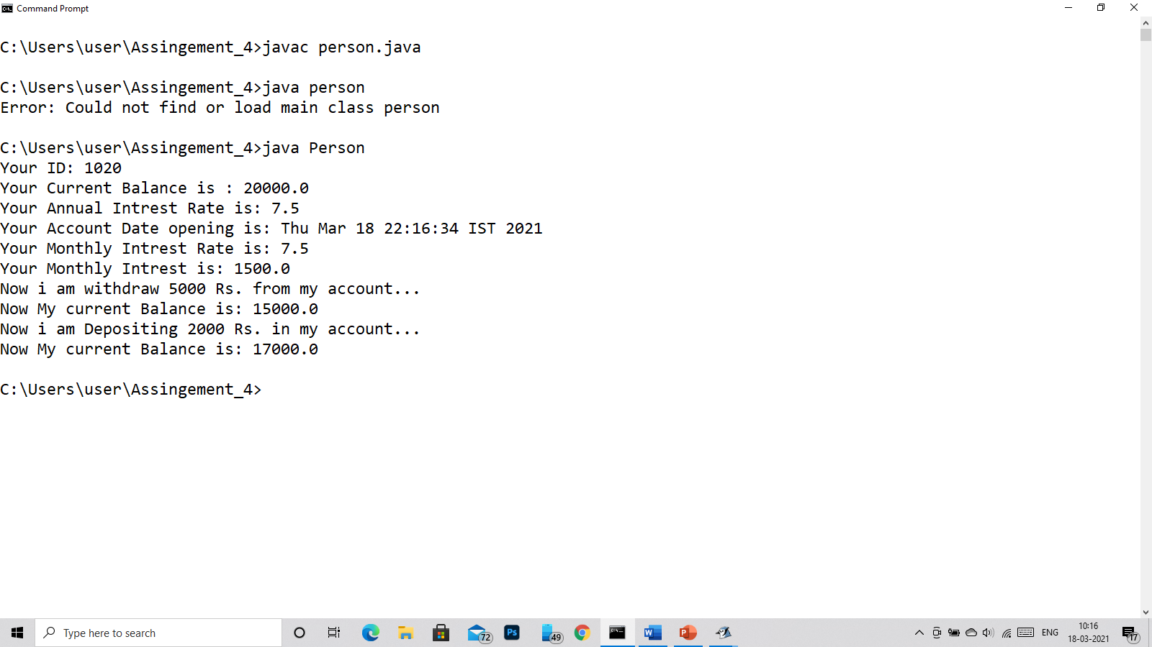

Q14)

import java.util.*;

class AnnualInvestment

{

double amt,rate;

public double calc(double amt,double mrate,int year)

{

double val;

val = Math.pow(1+mrate,year*12)*amt;

return val;

}

public static void main(String args[])

{

AnnualInvestment obj = new AnnualInvestment();

Scanner in = new Scanner(System.in);

System.out.println("Enter the Invertment amt: ");

double amt=in.nextDouble();

System.out.println("Enter the Annual Rate of Intrest: ");

double ain = in.nextDouble();

int i;

double mi=ain/1200;

System.out.println("Year\t\tValue");

for(i=1;i<=30;i++)

{

System.out.printf("%d",i);

System.out.printf("\t\t ");

System.out.printf("%11.2f",obj.calc(amt,mi,i));

System.out.println();

}

}

}

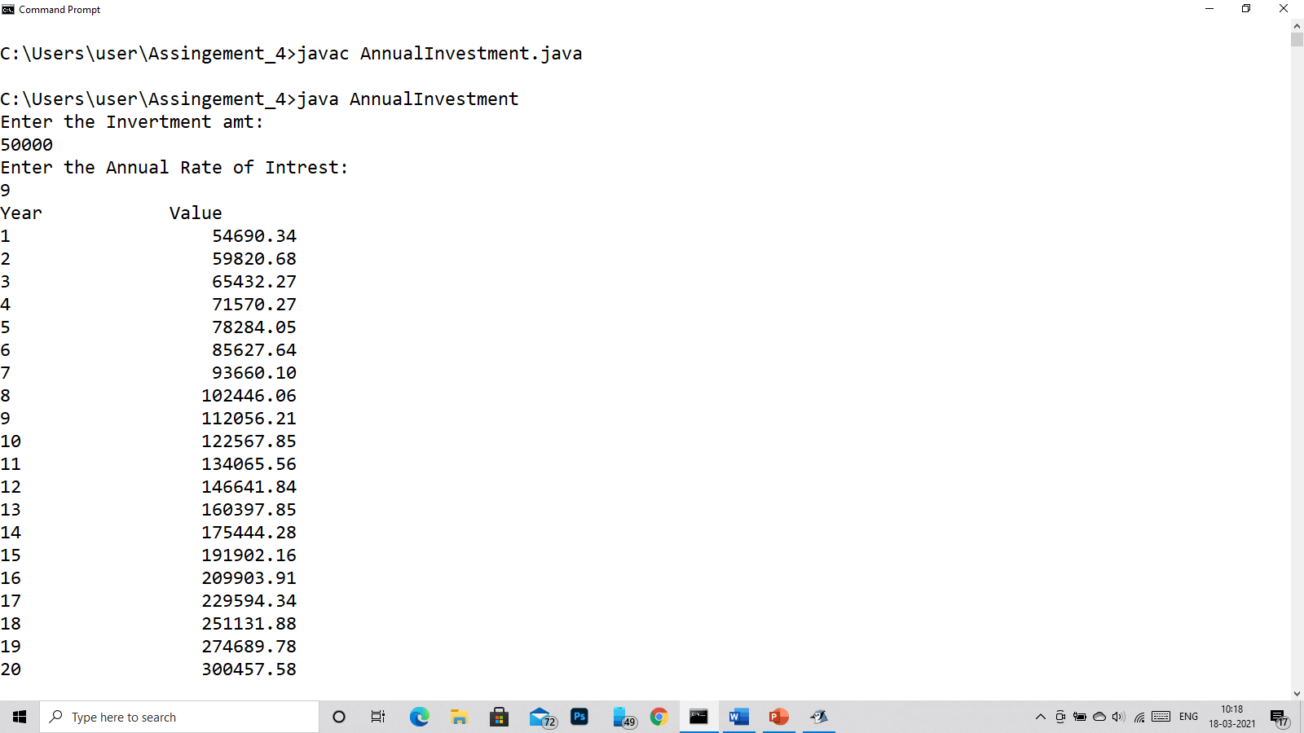 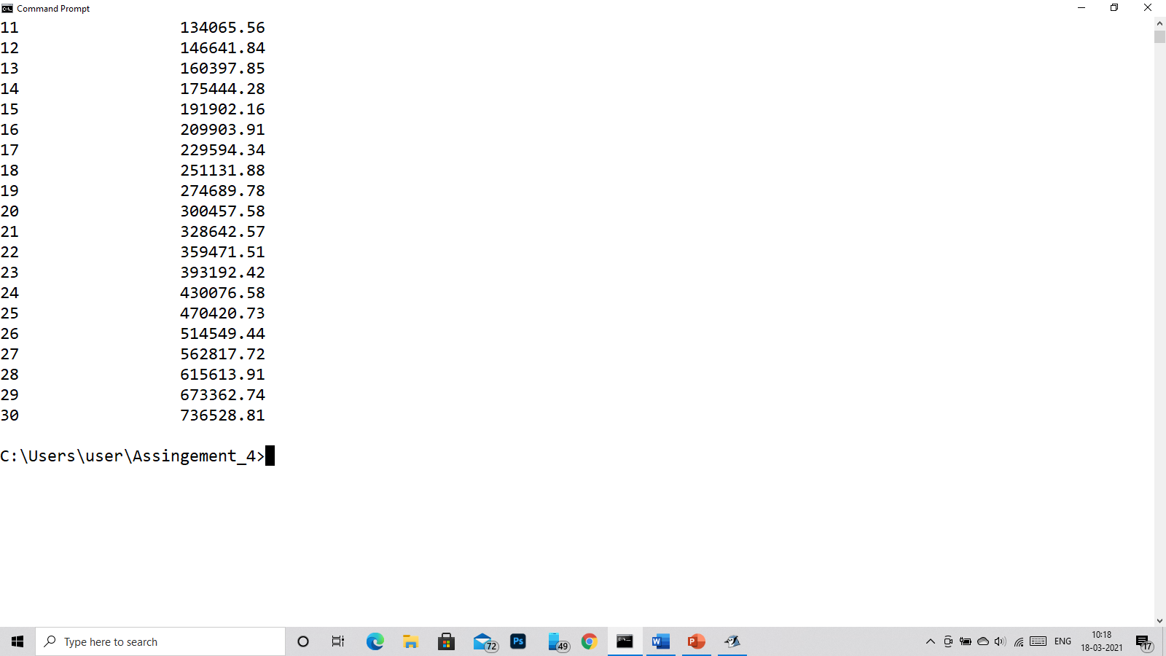

Q15)

import java.util.*;

class Header

{

double sqrt(double n)

{

return Math.sqrt(n);

}

boolean even(int n)

{

if(n%2==0)

return true;

else

return false;

}

void nmsg(String msg,int n)

{

for(int i=1;i<=n;i++)

{

System.out.println(msg);

}

}

void sales(double sale,double com)

{

//commision in %

sale = sale*(1-com/100);

System.out.println("The Sales price is: "+sale);

}

void loan(double amt,double ain,int year)

{

double val;

double n1,n2,r;

r=ain/12;

r=r+1;

double y= -12*year;

n1 = ain*amt/12;

n2= 1-(Math.pow(r,y));

val=n2;

System.out.printf("The Monthly repayment amt is Rs.: %11.2f",val);

}

public static void main(String art[])

{

Header obj = new Header();

System.out.println("The square root of 90 is.: "+obj.sqrt(90));

System.out.println("is 9 is an even number? ans.: "+obj.even(9));

obj.nmsg("I love Krishna",7);

obj.sales(3200,15);

obj.loan(500000,8,3);

}

}

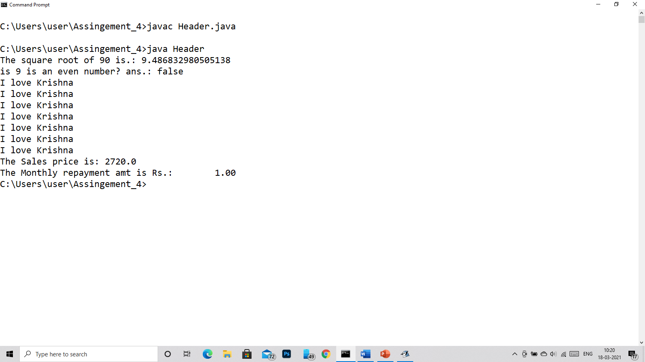

Q16) import java.util.*;

class Q16

{

public static void main(String args[])

{

int i,j;

int arr[]= new int[10];

double avg=1,sum=0;

Scanner in = new Scanner(System.in);

System.out.println("Enter the numbers: ");

for(i=0;i<10;i++)

{

arr[i]=in.nextInt();

sum+=arr[i];

}

//after it

avg=sum/10;

System.out.println("The Average is: "+avg);

System.out.println("The number above avg is.. ");

for(i=0;i<10;i++)

{

if(arr[i]>avg)

System.out.println(arr[i]);

}

}

}

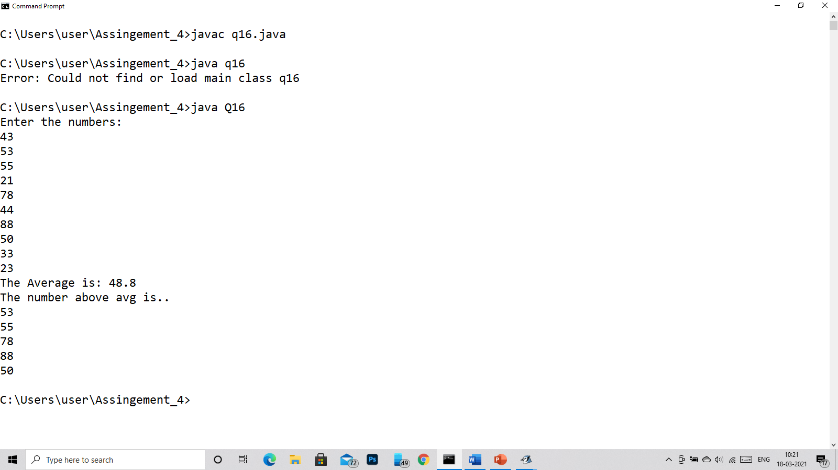

Q17)

import java.util.*;

class Q17

{

public static void main(String args[])

{

int i,j;

int arr[]= new int[10];

Scanner in = new Scanner(System.in);

System.out.println("Enter the numbers: ");

for(i=0;i<10;i++)

{

arr[i]=in.nextInt();

}

for(i=9;i>=0;i--)

{

int n = arr[i];

while(n!=0)

{

System.out.print(n%10);

n/=10;

}

System.out.print(" ");

}

}

}

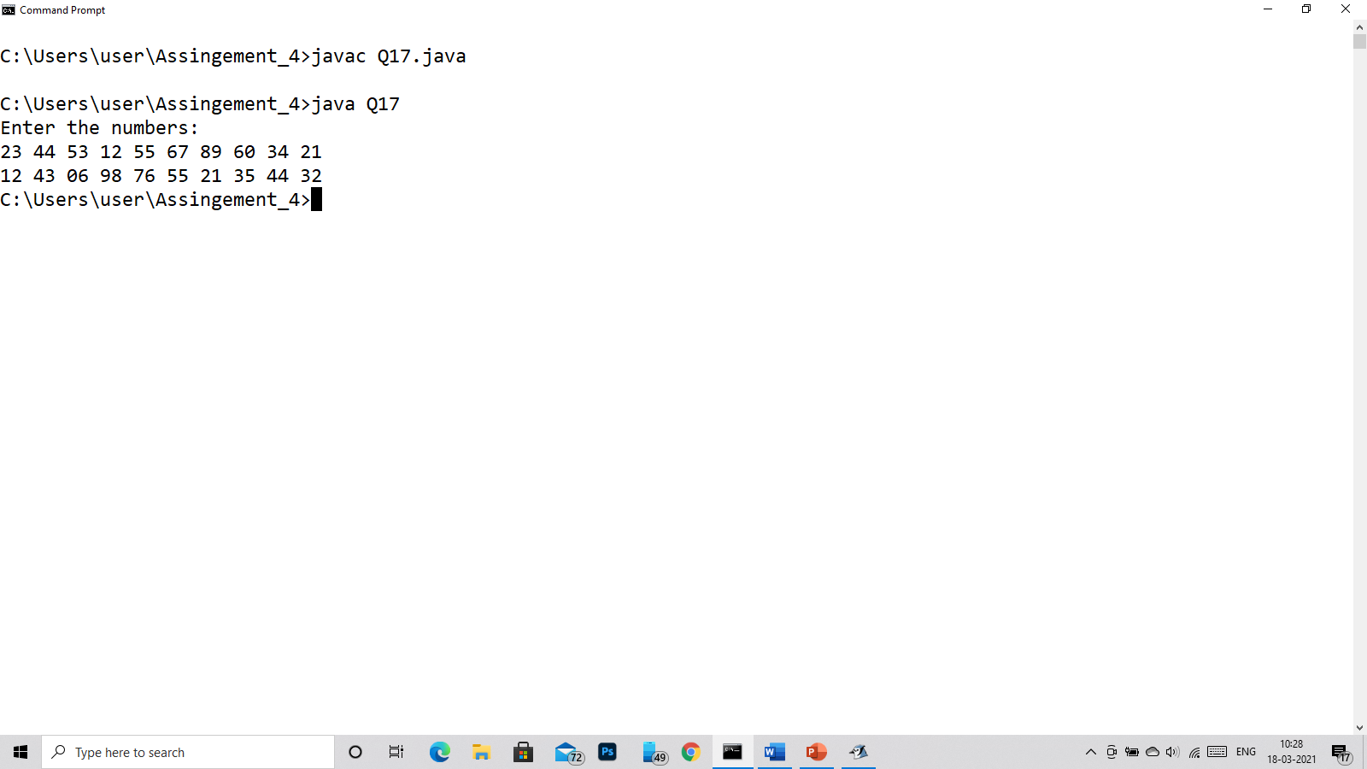

Q18)

class demothis

{

int num;

demothis()

{

num=200;

}

void display()

{

int num=100;

System.out.println("Number without this: "+num);

System.out.println("Number with this: "+this.num);

}

public static void main(String args[])

{

demothis obj = new demothis();

obj.display();

}

}

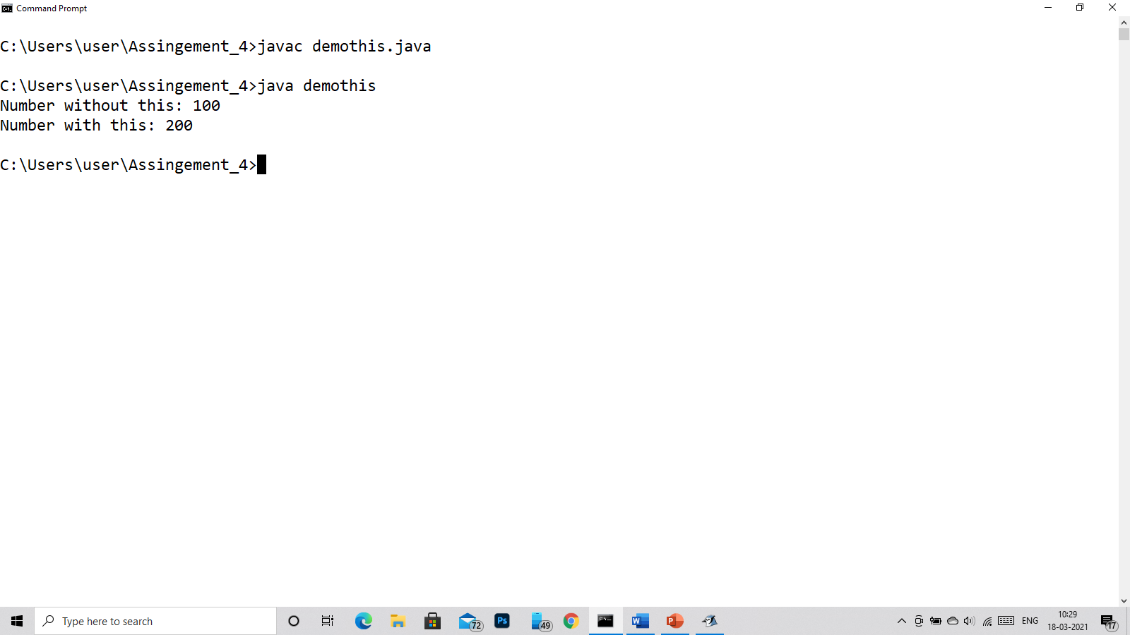

Q19)

class demostat

{

String name;

static String ceo;

int empid;

void display()

{

System.out.println(empid+" : "+name+" : "+ceo);

}

/*

* if the ceo change for ram then the ceo also change for

* vishnu so if we don't use static then if i change only for ram the it will not affect

* vishnu so after using static keyword in ceo now if i change for one then it will affect the other

*/

public static void main(String args[])

{

demostat ram = new demostat();

ram.name="Ram";

ram.ceo="Krishna";

ram.empid=1001;

demostat vishnu = new demostat();

vishnu.name="Vishnu";

vishnu.ceo="Vasu Dev Krishna";

vishnu.empid=1002;

ram.display();

vishnu.display();

}

}

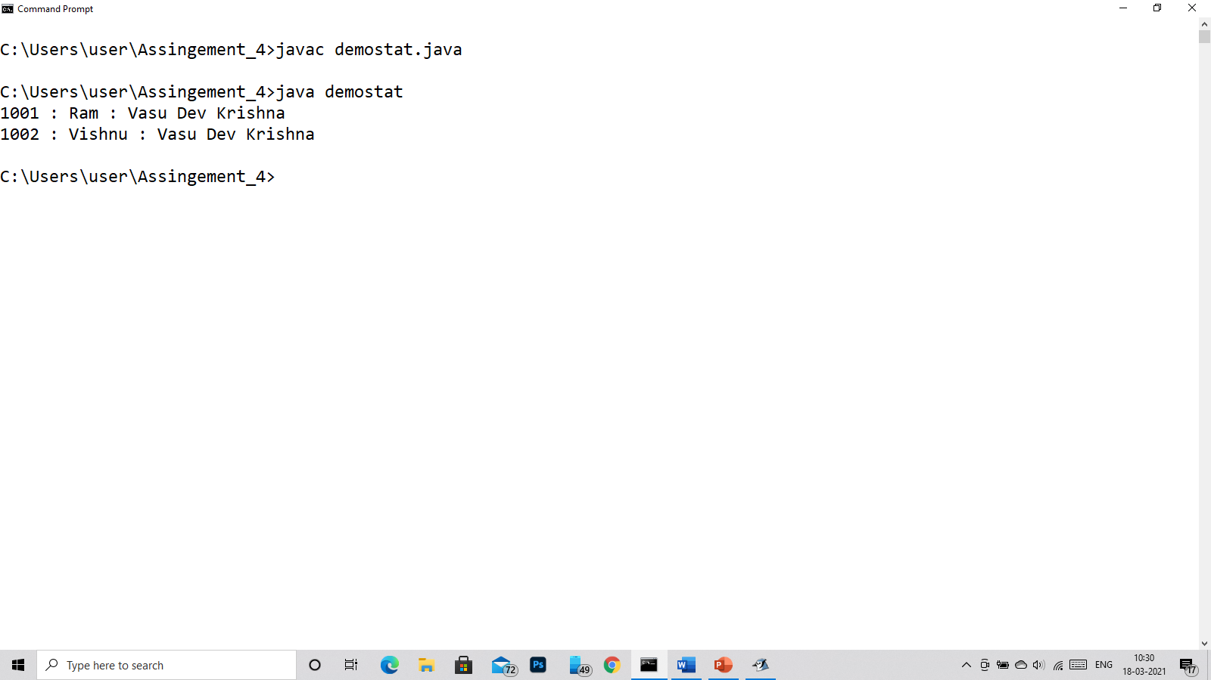

Q20)

import java.util.*;

class applesale

{

public static void main(String args[])

{

Scanner in = new Scanner(System.in);

float sale[] = new float[7],sum=0,avg=1;

String week[] = {"Monday","Tuesday","Wednesday","Thrusday","Friday","Saturday","Sunday"};

System.out.println("Enter the Sales per day: ");

for(int i =0;i<7;i++)

{

System.out.print("Sale for "+week[i]+": ");

sale[i]=in.nextFloat();

sum+=sale[i];

}

avg=sum/7;

System.out.println("The Average Sale of this week is: "+avg);

}

}

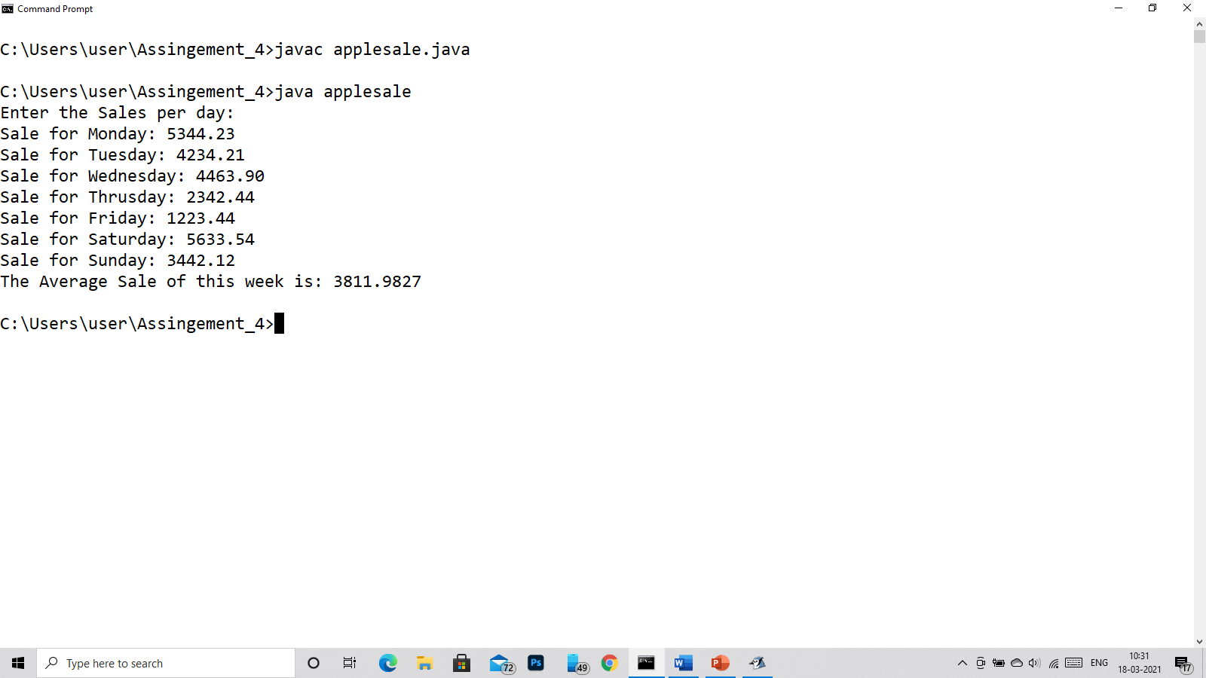

Q21)

import java.util.*;

class connum

{

public static void main(String args[])

{

int num;

Scanner in = new Scanner(System.in);

int i,j,temp,sum=0,n2,n1=0;

System.out.print("Enter the number: ");

num=in.nextInt();

int n= num;

while(num!=0)

{

n1=num%10;

n2 = num%100;

sum=sum+n2;

num=num/10;

}

sum=sum-n1;

System.out.println(sum);

}

}

